Activity 5: ACID Transactions
Samantha Krall
CST-236

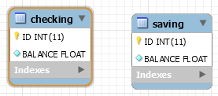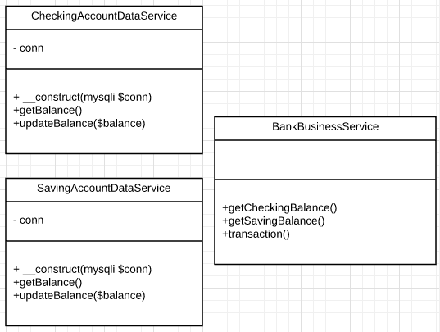

ACID (Atomicity, Consistency, Isolation, and Durability) concerns a transaction in a database system and what is needed in order to ensure accuracy, completeness and data integrity. Atomicity states that a transaction must be treated as an atomic unit. There must be no state in a database where a transaction is left partially completed. Consistency states that a database must remain in a consistent state after any transaction. No transaction should have any adverse effect on the data residing in the database. The database should be durable enough to hold all its latest updates even if the system fails or restarts. In a database system where more than one transaction are being executed simultaneously and in parallel, the property of isolation states that all the transactions will be carried out and executed as if it is the only transaction in the system. This design follows all of these rules. Since any transaction is within a function that is called, it is automatically fulfilled fully when it is initialized. This also allows for consistency and isolation. If autocommit mode is enabled, each SQL statement forms a single transaction on its own. By default, MySQL does a commit for each new connection with autocommit enabled, so MySQL does a commit after each SQL statement if that statement did not return an error. If a statement returns an error, the commit or rollback behavior depends on the error.

References:
Tutorialspoint.com. (n.d.). DBMS Transaction. Retrieved from https://www.tutorialspoint.com/dbms/dbms_transaction.htm

MySQL 5.6 Reference Manual :: 14.7.2.2 autocommit, Commit, and Rollback. (n.d.). Retrieved from https://dev.mysql.com/doc/refman/5.6/en/innodb-autocommit-commit-rollback.html

